Vocabulary: “Adiantar” / “Adiar” / “Remarcar”
1) Meetings/Appointments/Flights/etc.

a) “adiantar” (to an earlier time)
to move forward (to)
Podemos adiantar a reunião para as 10h?
Can we move the meeting forward to 10am?

b) “adiar” (to a later time)
to postpone (to) / to put off (to)/ to delay (to)
Podemos adiar a reunião para amanhã?
Can we postpone the meeting to tomorrow?
Can we put off the meeting to tomorrow? / Can we put the meeting off to tomorrow?
Can we delay the meeting to tomorrow?

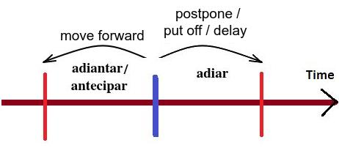

c) “remarcar” (to earlier or later)

Pronunciation:

USA: ree – ské – jool

UK: ree – shé – jool
to reschedule (for) / to move (to)
Podemos remarcar a reunião para as 10h?
Can we reschedule the meeting for 10am?
Can we move the meeting to 10am?
Podemos remarcar a reunião para amanhã?
Can we reschedule the meeting for tomorrow?
Can we move the meeting to tomorrow?

2) Other situations for “adiantar”
- to get done
Eu preciso adiantar esse trabalho.
I need to get on this work.

- to be ahead of schedule / to be behind schedule
O projeto está adiantado. O projeto está atrasado.
The project is ahead of schedule. The project is behind schedule.

- to advance (money)
Pode me adiantar uma parte do meu salário este mês, chefe?
Can you advance me a part of my salary this month, boss?
Can you give me a part of my salary in advance this month, boss?

- there is no point (+ gerund) / it’s not worth (+ gerund)
Não adianta falar inglês com o Pedro, ele só fala português.
There’s no point speaking English to Peter, he only speaks Portuguese. (verb: gerund)
It’s not worth speaking English to Peter, he only speaks Portuguese. (verb: gerund)
Exercise 1. Meetings/Appointments/Flights/etc. Translate to English:

1. Eu gostaria de adiar a minha consulta com o Dr. Emerson para amanhã.

_______________________________________________________________________

2. É possível adiantar a minha consulta com o Dr. Emerson para as 15h?

_______________________________________________________________________

3. Posso remarcar a minha consulta com o Dr. Emerson para as 17h na terça?

_______________________________________________________________________

Exercise 2. Other situations. Translate to English:

1. Meu chefe sempre me adianta 50% do meu salário.

_______________________________________________________________________

2. Minha chefe quer que eu adiante esse trabalho.

_______________________________________________________________________

3. Não adianta reagir a um assalto – é sempre perigoso.
_______________________________________________________________________

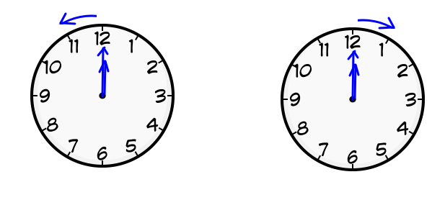
Clocks – Summer time

In autumn (or fall): In spring:
We have to set the clocks back one hour. We have to set the clocks forward one hour.
We have to put the clocks back one hour. We have to put the clocks forward one hour.
We have to move the clocks back one hour. We have to move the clocks forward one hour.
We will gain one hour of sleep! We will lose one hour of sleep!

To help us remember which way we adjust the clocks, we have an expression:
Spring forward / Fall back (pular para frente / cair para trás)
(Note: the words “jump”, “spring” and “leap” are synonymous.)

